**Budget Management**

1. Importance
2. Estimating costs to compare and select
3. Methods of Estimating
4. Managing the Budget
   1. Budget timeline
   2. Budget variances

**Importance of budget planning**

1. Cost is one of the three project constraints
2. A budget is a plan or forecast
3. Cost management also includes tracking and managing variances from the planned expenditures
4. Detailed estimates are important

**Estimating costs to compare and select projects**

1. Payback, rate of return or NPV (or combine them)
2. Need accurate numbers but must balance with the cost of getting more accurate estimates

**Estimating methods**

1. Analogous estimate
   1. Find a similar project or task and assume this one will be the same or similar
   2. The more experience the estimator has, the better this works
   3. Learn from each project
   4. DPCI (Darnell-Preston Complexity Index) can help with benchmarking
2. Parametric estimate
   1. Parameters such as the number of square feet for a building; the number of kitchens, bathrooms, etc. for a house.
3. Bottom-up estimating
   1. Estimate each item or task and add them together
   2. Generally more accurate but takes more effort to create

**Estimating Guidelines**

Don’t gold-plate: estimate what you expect, and meet that estimate

**Managing the Budget**

Cash flow

1. Make a plan of WHEN the outflows will occur, and ensure that the money is available on time
2. Contingency reserves
   1. For unexpected expenses that arise during the project
   2. There are almost always some surprises, but can’t predict at the start what it will be
   3. Project Manager does not allocate to the sub-projects but manages it centrally
   4. Can be spent and still be within the original project budget
3. Management Reserves
   1. For scope changes
   2. Not likely to be spent; not part of project baseline

**Reporting Progress: Earned value management**

**Budget Baseline and Project Cost Chart**

1. The project budget is usually shown graphically, illustrating the cumulative planned spending.
2. The typical shape for the budget curve is s-shaped, with less spending at the beginning and end of the project.
3. Add the periodic expenditures on a regular basis to create the Project Cost Chart.

**Schedule Variance: SV**

1. Difference between planned and actual progress
   * 1. SV=EV-PV
2. Positive value: the project is ahead of schedule
3. Zero: the project is on-time
4. Negative: the project is behind schedule

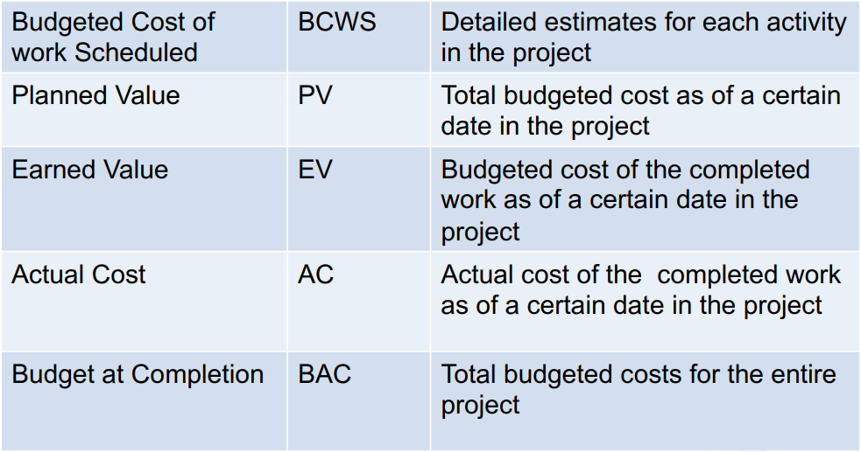**Cost Variance:** **CV**

1. The difference between the earned value and the actual cost is the cost variance:

CV=EV-AC

1. If positive, you are achieving more than you predicted for the money
2. If zero, you are right on the plan
3. If negative, you are achieving less than you predicted for the money

**Schedule Performance Index: SPI**

1. Compares progress on the scope to spend:

SPI = EV/PV

1. SPI less than one indicates the project is behind schedule
2. SPI of one is right on schedule
3. SPI greater than one the project is ahead of schedule

**Cost Performance Index: CPI**

1. Compares the budget spent to date with progress to date:

CPI=EV/AC

1. A value greater than one: under budget
2. Equal to one: on budget
3. Less than one: overspending the budget

**Estimated Cost to Complete the Project: ETC**

The formula to use depends on what the PM expects with regard to future project costs and whether the original budget assumptions remain valid

**ETC if past variances are not expected to continue**

**ETC = BAC – EV**

**ETC if past variances are expected to continue at the same level**

**ETC = (BAC – EV)/CPI**

**Estimated Final Project Cost: EAC**

**EAC = ETC + AC**

**Budget Timeline**

1. Contractual agreements often require partial payments
2. Prepare a schedule, based on contractual and other expenditure requirements\

**Budget Management Summary**

1. Cost estimations may be used to choose between options
2. Managing the budget includes
   1. Estimating costs and setting a budget
   2. Determining when the budgeted costs should occur
   3. Tracking expenditures
   4. Managing variances between the budget and the expenditures
3. Methods of Estimating
   1. Analogous, Parametric, Bottom-up
4. Managing the Budget
   1. Budget timeline
   2. Budget variances
5. Budgeting and Cost Management are important activities for project managers
6. There are several methods for estimating the costs
7. Estimated costs may be used to choose between options
8. Project progress and budget management are closely related and can be managed with indices: BCWS, PV, SV, AC, CV, SPI, CPI, ETC, BAC and EAC
9. Contingency funds allow for the unexpected
10. Reporting to the team and to management is an important component of budget management